COVID-19 and information technologies in the healthcare system of Ukraine

Nazar Beiar
Artem Zhydkov

TABLE OF CONTENTS

INTRODUCTION 2
IN-DEPTH REVIEW OF THE APP’S FUNCTIONALITIES 4
MOST COMMON PROBLEMS AND BUGS WITH THE APPLICATIONS 7
PRIVACY ISSUES AND DEBATES AROUND THE APPLICATION 8
SURVEY AND CONCLUSION 9
REFERENCES 10

INTRODUCTION

As the world plunged into an unprecedented epidemic calamity and the well-being of peoples was put at risk, countries began to introduce strict measures to prevent the spread of the virulent infection. To curb the spread of the virus, naturally, travel restrictions were introduced with many countries opting for the drastic ones – closing the borders entirely, disrupting thousands of businesses and plans. Consequently, residents of such countries were starting to become increasingly anxious and begin to frown upon the government’s arbitrariness. Therefore, to retain the favour of population, a solution which would meet the ends of both parties became not an option, but an absolute necessity. The countries were tasked with finding a way to keep the virus in check, whilst at the same time trying not to violate people’s freedom. Our home country, Ukraine, was no exception. In fact, the way Ukraine decided to tackle this problem may have surpassed other countries’ solutions in efficacy. As spring, 2020 took its toll on the people’s right to free movement and the borders began to open gradually, an application emerged, the sole aim of which was allowing the freedom of foreign travel under the condition of people confining themselves to their houses for the period of 14 days of continuous application usage.
This application provides automated control over compliance with obligatory 14-day self-isolation upon return. It is based on the experience of foreign countries that also use digital tools to ensure the safety of their citizens during the pandemic. The application did prove to be successful at enforcing self-isolation, in spite of the fact that its installation is in fact optional. Most people, however, choose to install it as the alternative is most unfavorable. According to the new law, people crossing the state border of Ukraine can elect one of the two options:

- Hospitalisation at specialised observation facilities (isolators);
- 14-day self-isolation at the place of residence provided the of the app "Act at Home";
Needless to say, that people would rather stay with their families than confine themselves to some random facility in Ukraine for 2 weeks. As a result, people opt for the installation and then are asked to confirm this decision in the application, by entering their phone number and receiving a 24-hour window to arrive at the place of self-isolation. People are allowed entry upon presenting the respective application screen with 24 hours countdown to the border control officer. As the people arrive at the place of self-isolation, they are requested to confirm it by taking a selfie with geolocation metadata.

IN-DEPTH REVIEW OF THE APP’S FUNCTIONALITIES

The application is about monitoring of the subject and controlling its self-isolation procedure. The basis of the application was create using experience of foreign countries which uses digital tools during the period of pandemic.
Main functions of the app:
- Confirmation of the place of self-isolation with determination of geolocation.
- Photo confirmation of stay at the place of self-isolation.
- Emergency call to the hotline of the Ministry of Health of Ukraine.
- Scheduled functionality for monitoring the development of symptoms.
Control of self-isolation is being held via random notifications that are sent to subject’s smartphone. First of all, the person should install “Action at home” to his/her cellphone and it’s not absolutely obligatory in case the person is willing to continue his/her self-isolation in a hospital of their choice. Once the application is installed, it is needed to choose the place of self-isolation which uses geolocation of the device so it should be done only once the person is in the place where he/she wishes to start their self-isolation. (fig. 1)
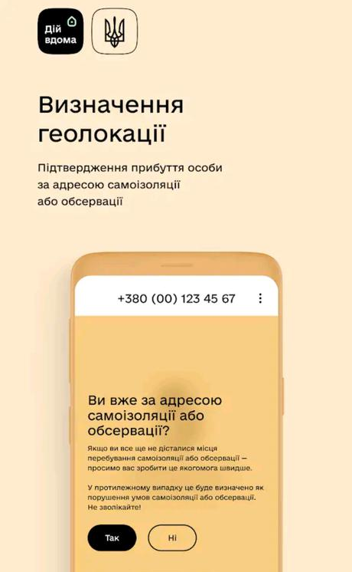

Figure 1 - the app determines geolocation of self-isolation
Once the person confirms its location, the application asks for several photos to take using smartphone’s camera in different angles. (fig. 2)
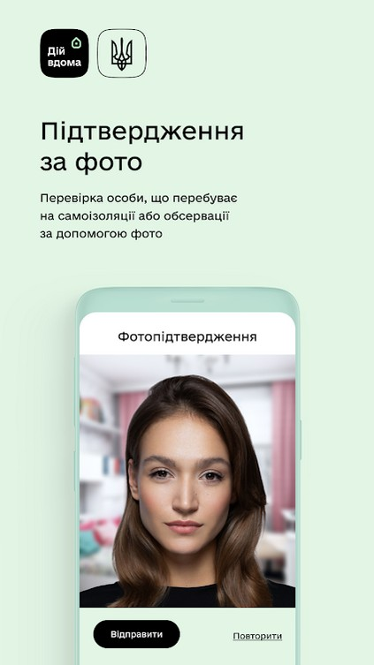
Figure 2 - photo confirmation

However, the application can turn down your check in if something goes wrong, for instance, the Figures were too dim or geolocation wasn’t sent properly, in this case there will be a screen with warning that self-check in failed and you should try again or contact for help. (fig. 3)
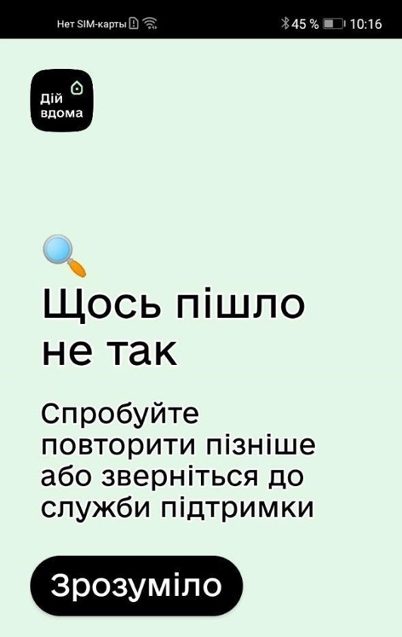
Figure 3 - warning screen
If self-check in went successful, there will be a screen with a number of remaining days of self-isolation. (fig. 4)
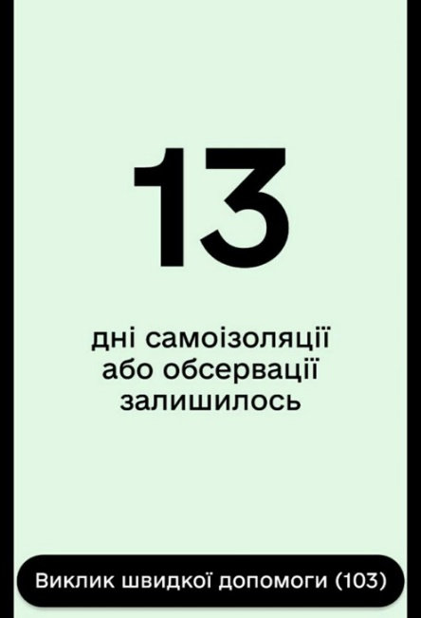
Picture 4 - Countdown
During all these days there will be a at least 3 notifications about check in sessions on the smartphone. Timing of these notifications is unpredictable so the person couldn’t cheat on the self-check in sessions. Self-isolation considered to be over once the countdown went zero and after last session there will be a screen stating that self-isolation period is over. (fig 5)
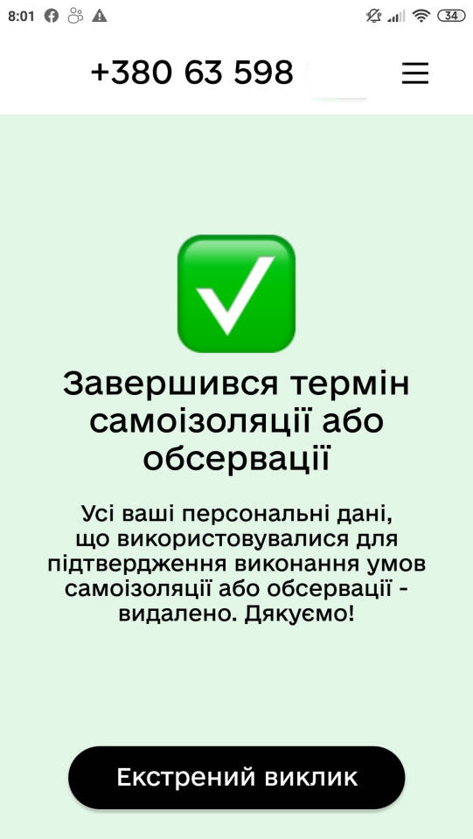
Figure 5 - Ending of self-isolation

MOST COMMON PROBLEMS AND BUGS WITH THE APPLICATIONS

The information about the advent of such application and the newly-introduced control measures were subjects alarming enough. But what actually brought the havoc and distaste was the user experience. According to the minister of digital technologies of Ukraine Michal Fedorov, the first release of the app was created in less than a week [1] and an update is expected which is supposed to fix most of the bugs, hoping to improve the atrocious user feedback the application received.

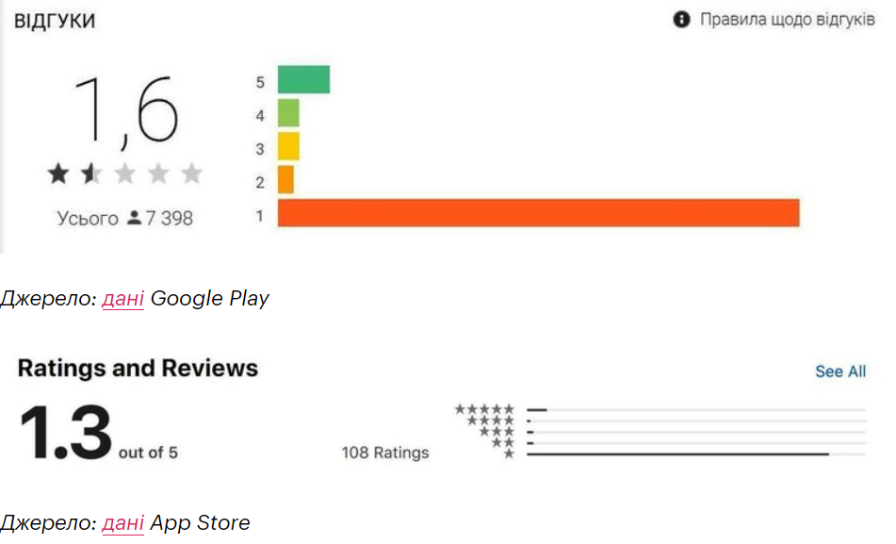
Figure 7. App rating for different platforms
According to Mind platform [2], the most heatedly debated bugs of the application are the following:
- App does not recognise the photo
As described in the previous chapter, the app used facial recognition technologies. Interestingly enough, most users find the implementation extremely lacking, with some people complaining about trying to submit a picture for ten times in a row and in different ambient light.
Ministry of Digital Transformation commented that most people simply do not understand how to use the app, with some taking the first and most important picture with a mask on and hence misleading the application algorithms.
- Self-isolation photo notifications come without sound
Notifications are said to sometimes be received without sound, which is very unsound, given that the main purpose of the application is to respond to them promptly.
Ministry of Digital Transformation commented that app works with the standard push notifications of the smartphone, it cannot override “Do not disturb mode” or “No Sound” mode.

PRIVACY ISSUES AND DEBATES AROUND THE APPLICATION

Since the application was launched in March of 2020 there were countless heated debates around it. The application was intended to be used only by self-aware and self-conscious people in order to help them with self-isolating and keeping covid-positive or potentially exposed to the virus from healthy population. And as a helper solution it was proposed as a voluntarily alternative to staying in hospital but there were some frictions with the Ukrainian law because not everyone has a smartphone or capable of operating one in case of age or some other reason and also the application actively tracks geolocation or used to track with some earlier versions. Many people were complaining that they don’t want to be constantly tracked, whether it intrudes with their personal life or some other motive. In fact, geolocation should’ve been sent only once the person is validating its presence in the place of self-isolation which he or she has chosen to spend all 14 days.
The citizen (or user), firstly, enters into voluntary civil relations, alternatively speaking at the level of the relationship between the ministry as a manufacturer of the application and the user, and secondly… "Voluntarily agrees to the processing of personal data that is commensurate with the provisions Part 2 of Article 11 of the Law of Ukraine "On Information" and Article 21 of the Constitution of Ukraine, which provides that only with your consent it is possible to collect, store, use, information about your whereabouts, health, etc., " say lawyers [3]. Nevertheless, Ministry of Digital Provisions changed the way of collecting the user’s data and with new revisions of the application geolocation has ever been sent only in the moment of sending of the selfie picture. The application is far from perfection and there is still much things ought to be improved but there is no issues with the law at least or so far because rules are constantly changing and who knows what happens next.
The law stipulates that that for the period of quarantine or restrictive measures related to the spread of coronavirus (COVID-19), and within 30 days from the date of its abolition, the collection and processing of personal data without the consent of individuals is allowed.
Within 30 days after the end of the quarantine period, such data shall be depersonalized and, if impossible, destroyed and the person notified.

SURVEY AND CONCLUSION

Following conclusions were made after interviewing 8 people, friends of mine who were undertaking self-isolation with the application:

- Police does control the compliance of the citizens, although it seems to be making it selectively (one person received calls from the police and the other didn’t with both violating the rules of self-isolation).
- General sentiment towards the application is negative.
- None of the surveyed received a fine, only polite requests to comply with the rules of self-isolation.
Following conclusions were made after creating a series of surveys in Telegram messenger in a travel-oriented group.

- Most people opt for PCR-tests and not self-isolation with the app, let alone in the isolator.
- The bugs of the application seem to be getting fixed gradually.
- The police does not enforce the quarantine or issue fines (based on the poll only) as not a single person voted for the fine option.

There are few to no ways to deceive the application itself, attempts like forbidding the app to use geolocation, feeding a photocard to the camera will yield no result as the app will start complaining and eventually a police call is expected. Interestingly enough, some lawyers say that it is entirely legal to refuse to install the application due to the fact that in order for the government to limit the freedom of movement, they must introduce either a martial law or nationwide emergency situation. Neither is in place at the moment in Ukraine, therefore if police makes a protocol and issues a fine, such decision can be easily disputed in court [4] with relative ease and moral compensation can be received. People obligingly accept the rules of self-isolation and install the application without even knowing that the government’s actions themselves are not necessarily in accord with constitution.

REFERENCES

- https://mind.ua/publications/20216397-probij-v-izolyaciyi-na-yaki-bagi-dij-vdoma-najchastishe-skarzhatsya-ukrayinci
- https://mind.ua/publications/20210863-dij-vdoma-yak-nepracyue-derzhavnij-zastosunok-dlya-kontrolyu-samoizolyaciyi
- https://www.ukrinform.ua/rubric-society/3001538-dodatok-dij-vdoma-bude-za-vami-steziti-ale-zvisno-akso-vi-pogodites.html
- https://www.youtube.com/watch?v=4azbG4QlhgQ

